Setting up the virtual Lab:

In this lab we need VMware Workstation 17 pro, Windows Server 2019 and Windows 10 Enterprise Edition for our labs and assignments.

- Download VMware Workstation pro:

https://www.techspot.com/downloads/downloadnow/189/?evp=f14a48a23bc560f5fbe81b8d83387b41&file=241

- VMware License key is here:

https://github.com/hegdepavankumar/VMware-Workstation-Pro-17-Licence-Keys/blob/main/VMware%20Workstation%20Pro%2017%20keys

- Microsoft Windows Server download here:
https://www.microsoft.com/en-us/evalcenter/evaluate-windows-server-2019
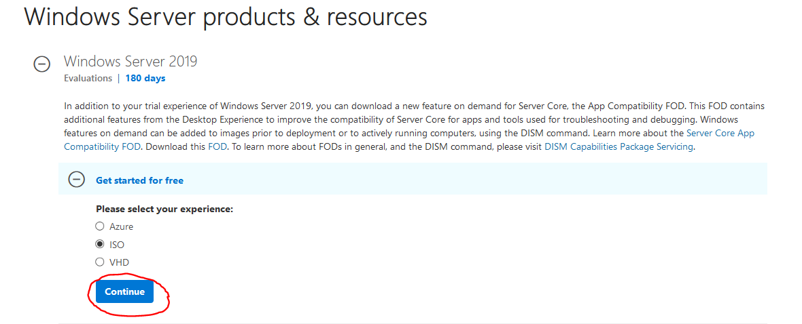
- Windows 10 download here:
https://www.microsoft.com/en-us/evalcenter/evaluate-windows-10-enterprise
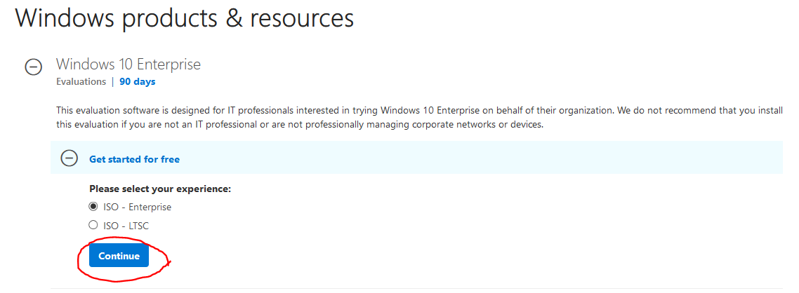
- Install Windows Server 2019 and Windows 10 on VMware Workstation pro here is a link to YouTube video that will show step by step installation instructions:
https://youtu.be/OAU2cod8z2E

